**Editing 3D segmentations of pleural thickenings combining image information and user-interaction**

Pleural mesothelioma is a malignant tumor of the pleura. It evolves from pleural thickenings which are a typical long-term effect of asbestos exposure. A diagnosis is performed by examining CT scans acquired from the patient's lung. The analysis of the image data is a very time-consuming task and is subject to strong inter- and intra-reader variability. Different full-automated approaches were developed to segment the relevant pleural thickenings. Due to the complex morphology of the thickenings, a correct segmentation cannot be guaranteed.

The target of the thesis is to develop tools, which allow the user to correct the segmentation by contributing meta-knowledge. This knowledge can include anatomical information of the lung and the surrounding organs, as well as information about the thickening morphology. On the one hand, considering this knowledge is relatively easy for humans, but it is a hard problem to design proper algorithms running automatically on a computer. On the other hand transferring human knowledge into a volumetric representation is a complex task, especially for non-technical users like physicians. This user group is more familiar with the image information in 2D slices:

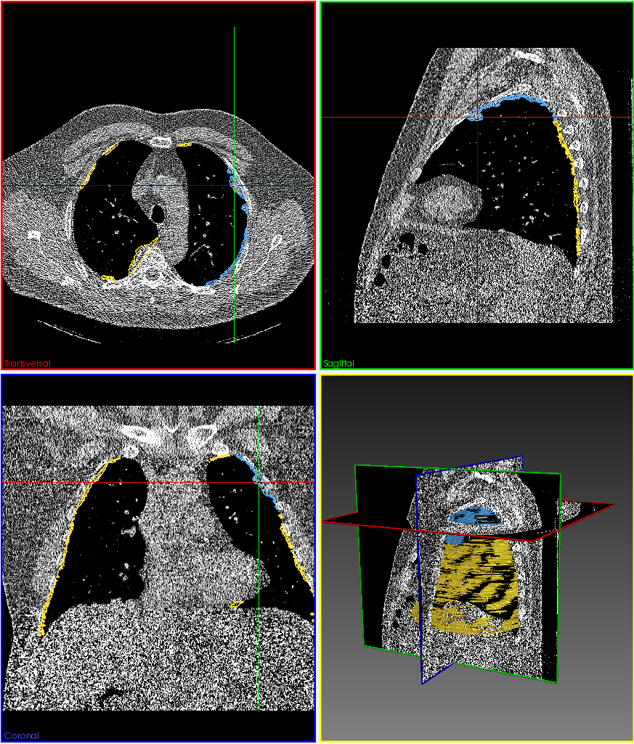

Therefore the developed tools allow the user to match his knowledge against 2D image-slices in the coronal, sagittal, transverse or any arbitrary plane, cutting the volumetric CT data. To obtain the 3D context of the morphology, the tools should not only consider information in the actual 2D plane, but of the whole 3D thickening.

Including image information in the editing process guarantees reproducible thickening boundaries. This reduces inter- and intra-reader variability of the resulting segmentation. This information can be included by e.g. gray-level homogeneity inside or outside the segment or edge information close to the boundary.